**DWBI**

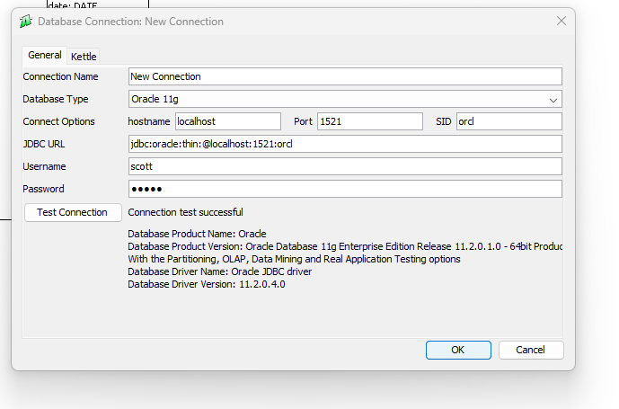

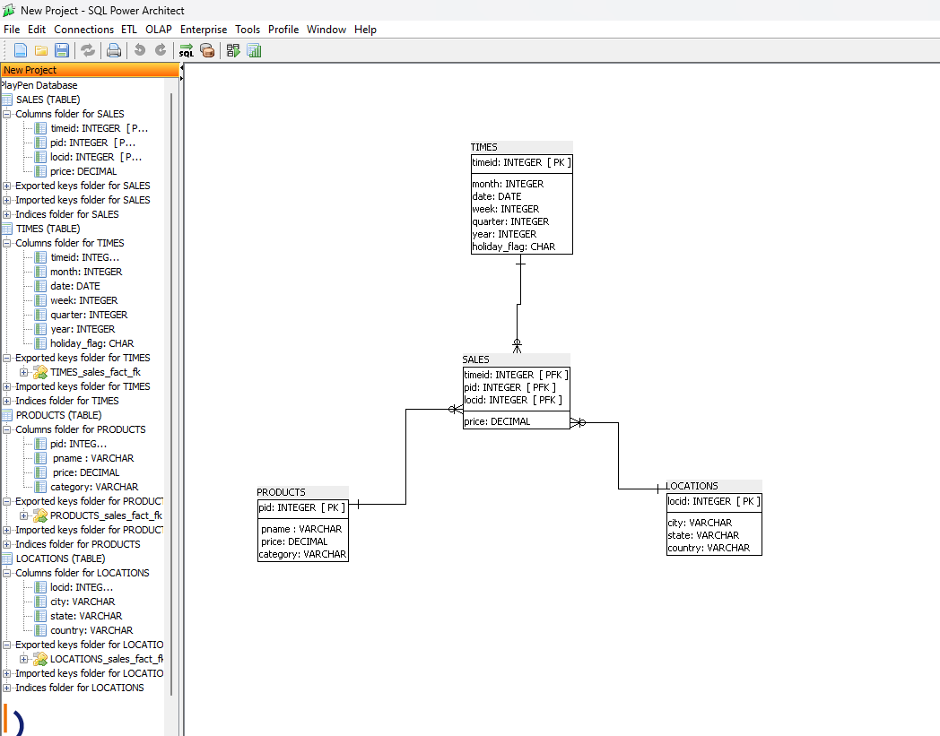

**SQL script:**

CREATE TABLE LOCATIONS (

locid INTEGER NOT NULL,

city VARCHAR NOT NULL,

state VARCHAR NOT NULL,

country VARCHAR NOT NULL,

CONSTRAINT locid PRIMARY KEY (locid)

);

CREATE TABLE PRODUCTS (

pid INTEGER NOT NULL,

_pname_ VARCHAR NOT NULL,

_price DECIMAL NOT NULL,

category VARCHAR NOT NULL,

CONSTRAINT pid PRIMARY KEY (pid)

);

CREATE TABLE TIMES (

timeid INTEGER NOT NULL,

month INTEGER NOT NULL,

date DATE NOT NULL,

week INTEGER NOT NULL,

quarter INTEGER NOT NULL,

year INTEGER NOT NULL,

holiday_flag CHAR NOT NULL,

CONSTRAINT timeid PRIMARY KEY (timeid)

);

CREATE TABLE sales_fact (

timeid INTEGER NOT NULL,

pid INTEGER NOT NULL,

locid INTEGER NOT NULL,

price DECIMAL NOT NULL,

CONSTRAINT sales PRIMARY KEY (timeid, pid, locid)

);

COMMENT ON TABLE sales_fact IS 'pid, pname , category , price';

ALTER TABLE sales_fact ADD CONSTRAINT LOCATIONS_sales_fact_fk

FOREIGN KEY (locid)

REFERENCES LOCATIONS (locid)

ON DELETE NO ACTION

ON UPDATE NO ACTION

NOT DEFERRABLE;

ALTER TABLE sales_fact ADD CONSTRAINT PRODUCTS_sales_fact_fk

FOREIGN KEY (pid)

REFERENCES PRODUCTS (pid)

ON DELETE NO ACTION

ON UPDATE NO ACTION

NOT DEFERRABLE;

ALTER TABLE sales_fact ADD CONSTRAINT TIMES_sales_fact_fk

FOREIGN KEY (timeid)

REFERENCES TIMES (timeid)

ON DELETE NO ACTION

ON UPDATE NO ACTION

NOT DEFERRABLE;

SELECT * FROM TAB;

DESC DEPARTMENT;

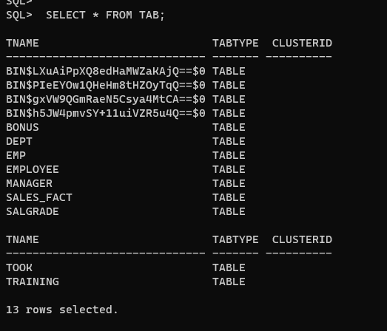

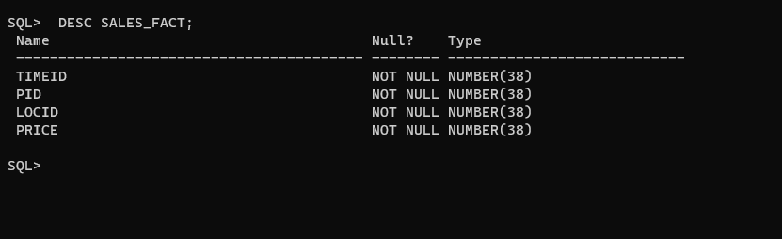

**CONCLUSION:**

In this practical, we successfully designed and populated a star schema using PL/SQL scripts. The schema consists of fact and dimension tables, including SALES as the fact table, and PRODUCTS, TIMES, and LOCATIONS as dimension tables.

This implementation demonstrates the use of relational schema design to support efficient querying for business intelligence purposes.